**CSS 458: Fundamentals of Computer Simulation Theory**

**Egyptian Ratscrew Simulation Model Analysis Report**

**Daniel Penkov & Joshua Medvinsky**

**Analysis:**

**Analysis Question: Which player skill is most effective?**

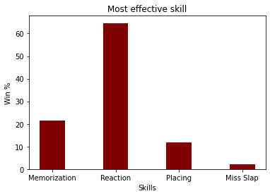

After testing over a 1000 simulations where in a group of 4 players, each player had a unique advantage in one skill over the other players, and aside from their one unique skill each player held an average value of 5 in all other skills. We discovered that reaction time was the most useful skill, and would win you over 60% of games if a player held an advantage in it over other players. This met our expectations as we expected reaction time to be the most important skill as it is in a real game outside our simulation.

As for the other skills, memorization came second holding about 20% of all wins, being able to have guaranteed slaps nets a player an edge over others and our simulation shows this. Placing came in third, this also met expectations as placing quickly throws your opponent off by blocking slaps that your opponent can receive and drawing miss slaps if placed correctly before they slap. This strategy is also a double edge sword as a player can prevent a slap that they otherwise would have received if they slapped on a valid slap instead of placing a card on it. Due to this it met expectations that it wouldn’t be too much higher than 10% as this strategy can backfire on a player. For miss slaps the ability to not slap on a invalid slap does give a player an advantage by not burning a player’s card, but this skill does not give a player much of an advantage as it would only save a player around 5 cards a game.

**Analysis Question: How does a player’s reaction skill value affect their win favorability?**

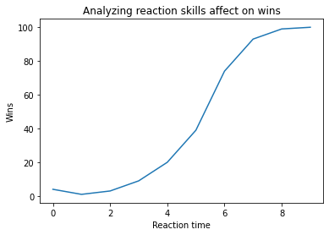

For this analysis test we simulated a player in a game against other average players in which this player went from 0-10 in the reaction time, incrementing by one every hundred games. The player simulates a hundred games at each skill level. From this analysis we discovered that as the reaction time increases past 5, the player's chance to win significantly increases, before 5 the player's chance only slightly increases. As we saw in our previous analysis since reaction time is one of the most components to winning, this graph meant expectations in terms of increasing your chance to win increasing as reaction time increased.

**Analysis Question: How does a player’s memorization skill value affect their win favorability?**

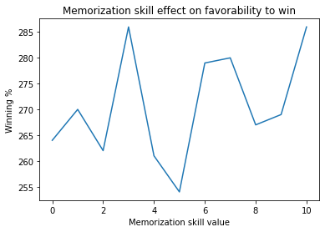

When analyzing the memorization skill’s effect on favorability to win, we simulated 1000 games between 4 players 10 times, with player 1 getting 1-10 as their placing skill value in every 1000 simulations. The resulting analysis plot shows that there is a clear positive correlation between winning percentage and cranking up the memorization skill. Up to 3% more games can be won with the practice of memorization being used in the game.

**Analysis Question: How does a player’s placing skill value affect their win favorability?**

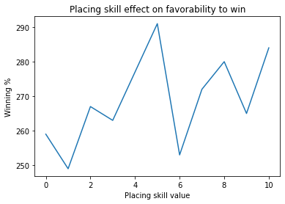

When analyzing the placing skill’s effect on favorability to win, we simulated 1000 games between 4 players 10 times, with player 1 getting 1-10 as their placing skill value in each 1000 simulations. The resulting analysis plot shows us that overall having a greater placing skill makes a player’s favorability to win a game increase by up to 4 percent as you crank up this skill. It seems that at around 5, the placing skill grants placing speeds and tactics that allow the most success. This may be due to the fact that between 4 and 6, placing skill has a sweet spot where a player does not place cards too fast, resulting in potentially placing out of turn and having to burn cards, or too slow, resulting in other players having an edge on being able to react quicker than them to their card placements.

**Analysis Question: How does the number of players in a game affect the deviation of slap sizes?**

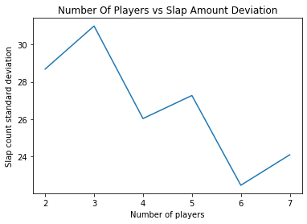

To utilize our simulation model, we ran 100 simulations of the game 6 times, incrementing the amount of players participating in the game every time (2 to 7 players). All players were given average skill values for all skills, so as not to add any noise to the input of the simulation. What we found in doing this analysis simulation was that there is an overall negative correlation that can be seen between the amount of players and the slap count variance within games. This relationship, however, also includes jumps at 3, 5, and 7 players, leading us to believe that there is potentially a relative inverse effect when there are an odd number of people in the game rather than an even one. 100 simulations may not be enough simulations to make this hypothesis, but we do believe that the inclusion of an odd player could result in players having an overload of distractions and honing in on more slaps as a result. This hypothesis has additional support from the fact that the variance is higher overall with less players, meaning that additional player distractions, among other possible factors led on by an increase in players, could lead to players honing in and being more consistent with the amount of slaps they win as a group.

**Analysis Question: How does a player’s reaction skill affect the length of the game?**

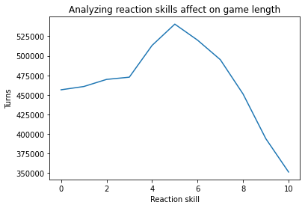

For this analysis we ran 1000 simulations 10 times, in which a player played in a game where his reaction skill was 0 and incremented by 1 until he reached 10. Each incrementation ran 1000 times, in our results we found that the amount of turns slowly increased until the player reached a reaction skill of 5, then the amount of turns this player had significantly drops as his reaction skill increases. This met our expectations as the faster a player's reaction time is the quicker he will be able beat his opponents and shorten the total amount of turns that is played.

**Analysis Question: How does a player’s memorization skill affect the length of the game?**

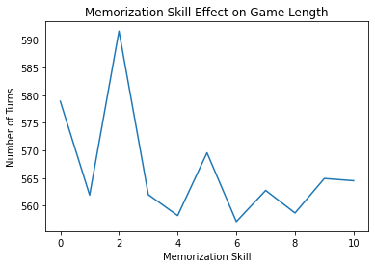

For this analysis simulation, we ran 1,000 simulations of our game with 4 players, for 1-10 memorization skill values for all of the players, while the rest of their skill values stayed average (5). The total simulations came out to 10,000. The length of a single game is measured by the number of turns or cards placed down in a game, and the averages of all games simulated are represented by the “Number of Turns” axis. Overall, this plot shows a slight negative correlation between memorization skill and the number of turns carried out in a given game, however, there are significant peaks at the 2 and 5 memorization skill values. Some insight we can take away from this may be that at around 2 and 5 memorization skill values, players tend to provide some game-lengthening behavior at a higher rate than other values. Such behaviors include lack of memory-induced slaps, as well as misslaps that may create more slap potential around a value of 4. EIther way, there is still a slight relationship clearly shown that illustrates that as memorization skill values increase, the length of games tends to decrease by around 15-20 turns. This is most likely due to memorization creating some portion of big slaps that create squeeze outs of losing players.

**Analysis Question: How does a player’s placing skill affect the length of the game?**

10000 total simulations

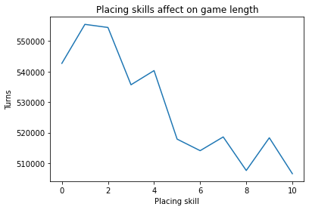

For this analysis we ran 1000 simulations 10 times, in which a player played in a game where his placing skill was 0 and incremented by 1 until he reached 10. Each incrementation ran 1000 times, in our results we found that there were more turns if the placing skill was lower and as the placing skill increased the game length significantly decreased.

**Analysis Question: How does the number of players in a game affect the number of slaps won?**

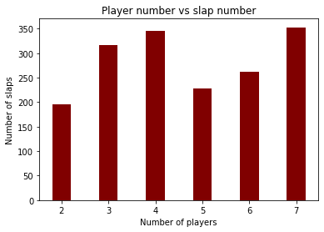

For this simulation analysis, we wanted to see if there was a meaningful relationship between the number of players in a simulated game, and the number of slaps won in a given game. From the corresponding bar graph, we had a difficult time seeing if this relationship had any legitimate hold, as these “2 stairways” seemed to bring a lot of contradicting ideas to the table. The data showed that after simulating each number of players 100 times, 2 and 5 player games had the least amount of slaps won by a relatively large margin, followed by the rest of the player numbers. Similarly to our analysis of slap count standard deviations, we think that there may be more distractions and miss lap opportunities coming from games with 2 or 5 players, leading to there being less overall slaps in these game sizes. Certainly it seems these game sizes would result in less slaps at the table.

**Analysis Question: How does the average slap size change in every stage of a game?**

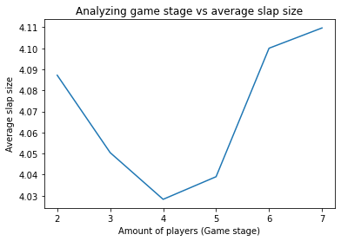

For this analysis we looked at the game stage(The total amount of players in a game) vs the average slap size. The main discovery from this was that the average slap size did not have an extreme variation depending on the amount of players in a game. We did find that 4-5 players had the lowest average slap size, and 2,6,7 had larger slap averages.

**User Manual:**

**When creating a player:**

p.player(name, memorization skill, reaction skill, placing skill, miss slap skill)

(skills are from 1-10)

**Creating players and playerList:**

playerOne = p.player("Player 1", 5,5,5,5)

playerTwo = p.player("Player 2", 5,5,5,5)

playerThree = p.player("Player 3", 5,5,5,5)

playerList = [playerOne,playerTwo,playerThree]

**Utilizing sim_x_games function:**

If the user wishes to simulate a certain number of games call the sim_x_games method and pass in the number of games you wish to simulate as well as a list of players you wish to call for this class

For example:

**sim_x_games(100,playerList)**

**Utilizing sim_one_game function:**

If a user wishes to simulate one game and receive a play by play for every action of the game the user can either call in sim_x_games and pass in 1 or directly call the sim_one_gamefunction as such:

**sim_one_game(playerList, 1)**

If a user doesn’t wish to manually create players they can also call and pass in the dummy_player() function in place of the playerList

All ranges and values used to calculate reaction, memorization, and placing performances were done in relation to data collected on card memorization amounts, placing times, and reaction times of us and other players. This includes chances to slap, misslap, and memorize cards.

**Commit History Screenshot:**

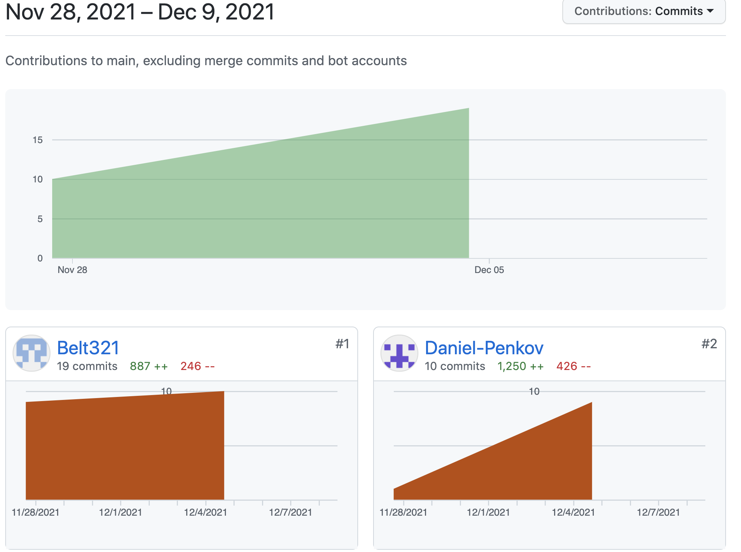

**Narrative Explanation for commits**:

Contributor github commits do not accurately reflect the work done by commiters. We both did an equal amount of work in the completion of all parts of this project.

**Github repository**: https://github.com/Daniel-Penkov/CSS458_FinalProject